La Palma Earthquakes
Steve Purves
Rowan Cockett
2024-02-23
Abstract
In September 2021, a significant jump in seismic activity on the island of La Palma (Canary Islands, Spain) signaled the start of a volcanic crisis that still continues at the time of writing. Earthquake data is continually collected and published by the Instituto Geográphico Nacional (IGN). …

1 Introduction
_{Source: Article Notebook}
_{Source: Article Notebook}
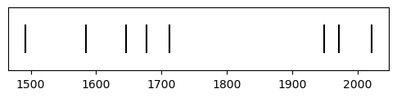
Figure 1: Timeline of recent earthquakes on La Palma
_{Source: Article Notebook}
_{Source: Article Notebook}
Based on data up to and including 1971, eruptions on La Palma happen every 79.8 years on average.
_{Source: Article Notebook}
Studies of the magma systems feeding the volcano, such as Marrero et al. (2019), have proposed that there are two main magma reservoirs feeding the Cumbre Vieja volcano; one in the mantle (30-40km depth) which charges and in turn feeds a shallower crustal reservoir (10-20km depth).
_{Source: Article Notebook}
Eight eruptions have been recorded since the late 1400s (Figure 1).
_{Source: Article Notebook}
Data and methods are discussed in Section 2.
_{Source: Article Notebook}
Let $x$ denote the number of eruptions in a year. Then, $x$ can be modeled by a Poisson distribution
$$p\left(x\right)=\frac{e^{−λ}λ^{x}}{x!} \left(1\right)$$
where $λ$ is the rate of eruptions per year. Using Equation 1, the probability of an eruption in the next $t$ years can be calculated.
_{Source: Article Notebook}
Table 1: Recent historic eruptions on La Palma
Name | Year
Current | 2021
Teneguía | 1971
Nambroque | 1949
El Charco | 1712
Volcán San Antonio | 1677
Volcán San Martin | 1646
Tajuya near El Paso | 1585
Montaña Quemada | 1492

Table 1 summarises the eruptions recorded since the colonization of the islands by Europeans in the late 1400s.
_{Source: Article Notebook}
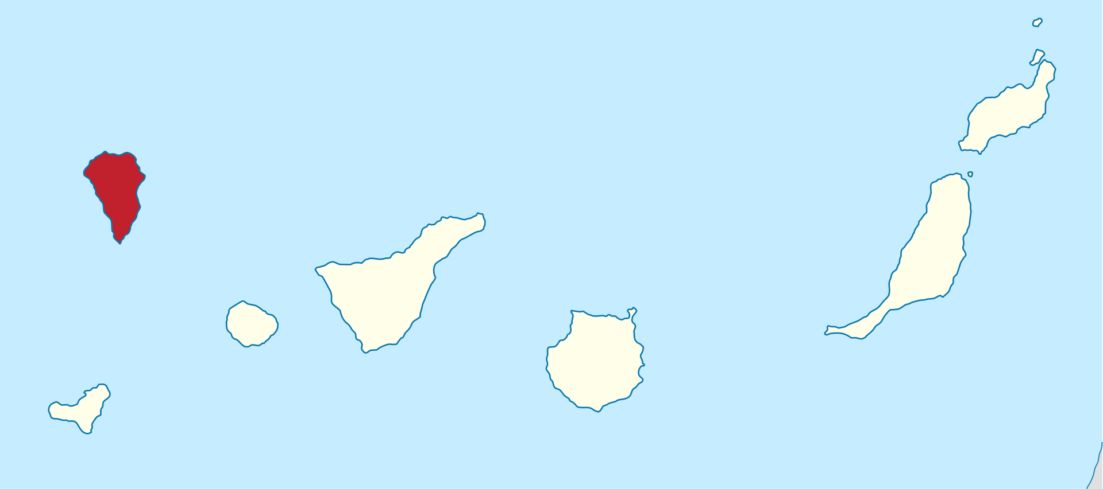
Figure 2: Map of La Palma
La Palma is one of the west most islands in the Volcanic Archipelago of the Canary Islands (Figure 2).
_{Source: Article Notebook}
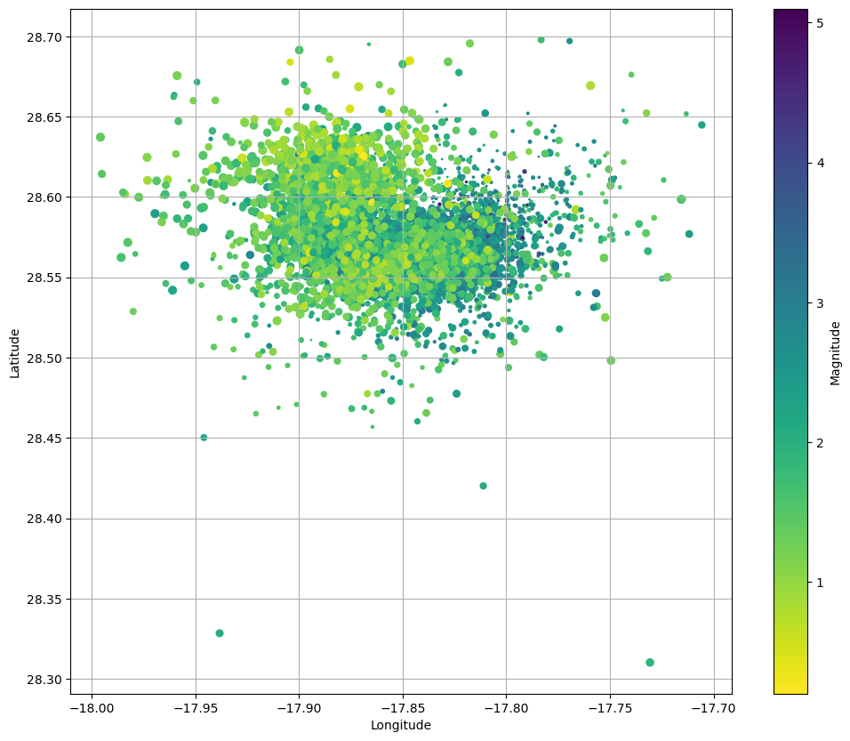
Figure 3: Locations of earthquakes on La Palma since 2017.
_{Source: Article Notebook}
Figure 3 shows the location of recent Earthquakes on La Palma.
_{Source: Article Notebook}

2 Data & Methods
_{Source: Article Notebook}

3 Conclusion
_{Source: Article Notebook}

References
_{Source: Article Notebook}
Marrero, José, Alicia García, Manuel Berrocoso, Ángeles Llinares, Antonio Rodríguez-Losada, and R. Ortiz. 2019. “Strategies for the Development of Volcanic Hazard Maps in Monogenetic Volcanic Fields: The Example of La Palma (Canary Islands).” Journal of Applied Volcanology 8 (July). https://doi.org/10.1186/s13617-019-0085-5.

